**COMP1661 Logbook Upload Template**

1 Introduction

2 Exercise 1: Create a PhoneGap App utilizing the Notification API

1. **Basic Information**

|  |  |
| --- | --- |
| 1.1 Student name | **DINH NGOC HUNG Login id: GCH15253** |
| 1.2 Who did you work with? Note that for logbook exercises you are allowed to work with one other person as long as you give their name and login id and both contribute to the work. You need to provide evidence who did what. | **independent** |
| 1.3 Which Exercise is this? Tick as appropriate. | **Create a PhoneGap App utilizing the Notification API** |
| 1.4 How well did you complete the exercise? Tick as appropriate. | * I tried but couldn't complete it * I did it but I feel I should have done better * I did everything that was asked * I did more than was asked for |
| 1.5 Briefly explain your answer to question 1.4 |  |

1. **Exercise answer**
   1. **Screen shots demonstrating what you achieved**

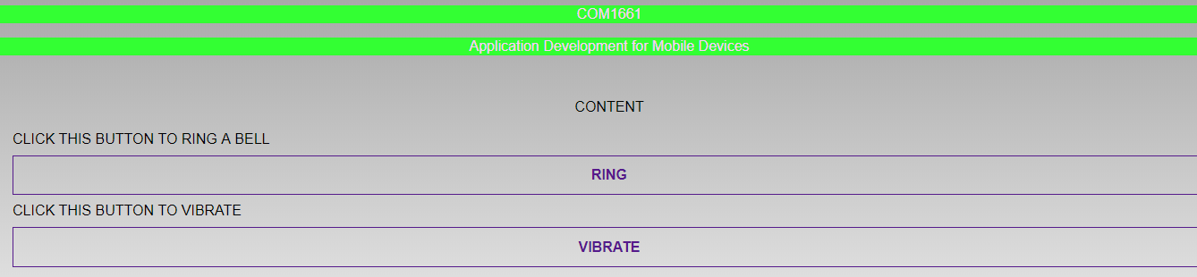

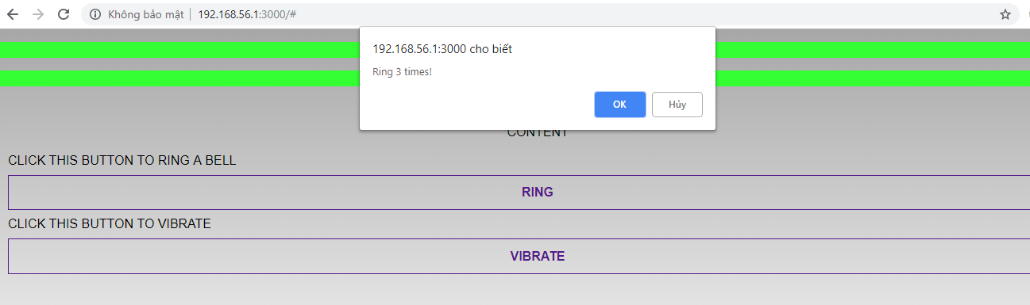

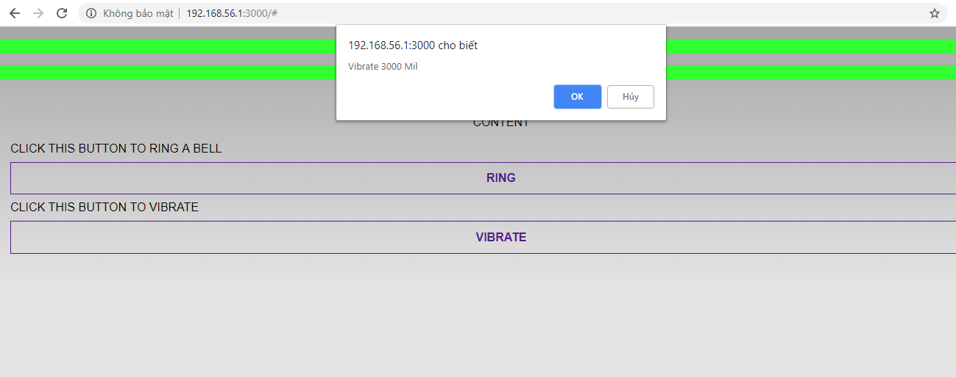

**2.2 Code that you wrote**

**HTML code**

<head>

<meta charset="utf-8" />

<meta name="format-detection" content="telephone=no" />

<meta name="msapplication-tap-highlight" content="no" />

<meta name="viewport" content="user-scalable=no, initial-scale=1, maximum-scale=1, minimum-scale=1, width=device-width" />

<!-- This is a wide open CSP declaration. To lock this down for production, see below. -->

<link rel="stylesheet" type="text/css" href="css/index.css" />

<title>Notification</title>

<link rel="stylesheet" href="css/jquery.mobile.icons.min" />

<link rel="stylesheet" href="css/huhu.css" />

<link rel="stylesheet" type="text/css" href="css/index.css" />

<link rel="stylesheet" href="http://code.jquery.com/mobile/1.4.5/jquery.mobile-1.4.5.min.css" />

<script src="http://code.jquery.com/jquery-1.11.1.min.js"></script>

<script src="http://code.jquery.com/mobile/1.4.5/jquery.mobile-1.4.5.min.js"></script>

<link rel="stylesheet" href="css/jquery.mobile.icons.min" />

<link rel="stylesheet" href="css/urglyTheme.css" />

</head>

<body>

<section id="page" data-role="page" >

<header data-role="header">

<p class="hi" style="text-align: center;text-transform: none">COM1661</p>

<p class="hi"style="text-align: center;text-transform: none">Application Development for Mobile Devices</p>

</header><!-- /header -->

<article role="main" class="ui-content">

<p style="text-align: center">Content</p>

<div>

Click this button to ring a Bell

<a href="#" id ="ring" class="ui-btn" data-type="button" content-type="button">Ring</a>

</div>

<div>

Click this button to vibrate

<a href="#" class="ui-btn" id="vibrate" data-type="button" content-type="button">Vibrate</a>

</div>

</article><!-- /content -->

<footer data-role="footer" style="">

<p style="text-align: center;text-transform: none"></p>

</footer><!-- /footer -->

</section><!-- /page -->

<script type="text/javascript" src="cordova.js"></script>

<script type="text/javascript" src="js/index.js"></script>

<link rel="stylesheet" href="css/jquery.mobile.icons.min" />

<link rel="stylesheet" href="css/huhu.css" />

</body>

</html>

**Fuction code**

$("#ring").click(function(event) {

navigator.notification.confirm(

'Ring 3 times!', // message

onConfirm, // callback to invoke with index of button pressed

'Do you want Ring your phone?', // title

['Accept','Exit'] // buttonLabels

);

});

$("#vibrate").click(function(event){

navigator.notification.confirm(

"Vibrate 3000 Mil", // message

onVibrate, // callback to invoke with index of button pressed

'Do you want Vibrate your phone?', // title

['Accept','Exit'] // buttonLabels

);

});

function onVibrate(buttonIndex) {

// alert('You selected button ' + buttonIndex);

//make 3 beep

navigator.vibrate(3000);

}

function onConfirm(buttonIndex) {

// alert('You selected button ' + buttonIndex);

//make 3 beep

navigator.notification.beep(3);

}

**CSS code**

.hi{

background: #33FF33;

color :#FFCCFF;

}

Exercise 2: Create a PhoneGap App data entry screen

1. **Basic Information**

|  |  |
| --- | --- |
| 1.1 Student name | **DINH NGOC HUNG Login id: GCH15253** |
| 1.2 Who did you work with? Note that for logbook exercises you are allowed to work with one other person as long as you give their name and login id and both contribute to the work. You need to provide evidence who did what. | **independent** |
| 1.3 Which Exercise is this? Tick as appropriate. | Create a PhoneGap App data entry screen |
| 1.4 How well did you complete the exercise? Tick as appropriate. | * I tried but couldn't complete it * I did it but I feel I should have done better * I did everything that was asked * I did more than was asked for |
| 1.5 Briefly explain your answer to question 1.4 |  |

1. **Exercise answer**
   1. **Screen shots demonstrating what you achieved**

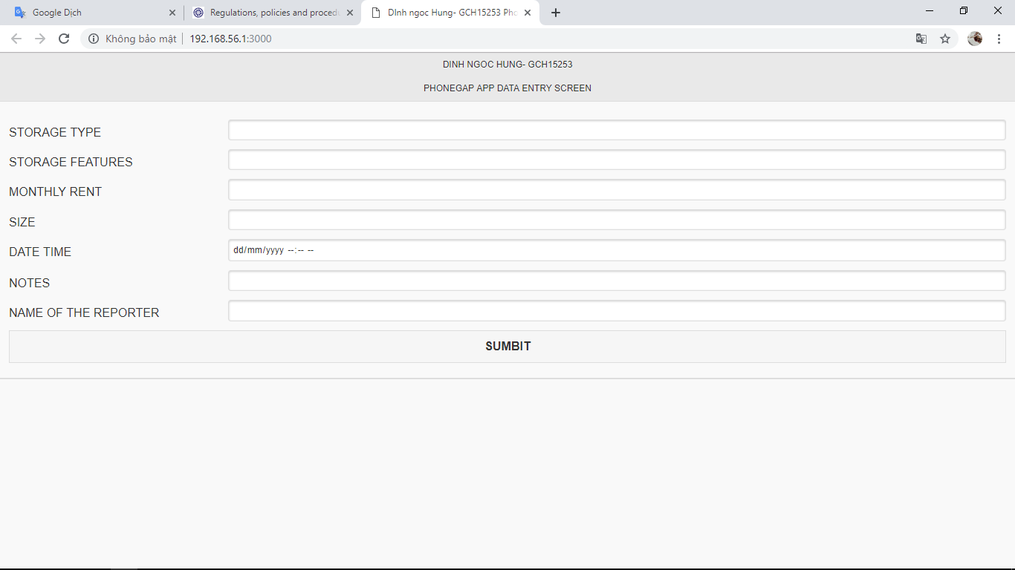

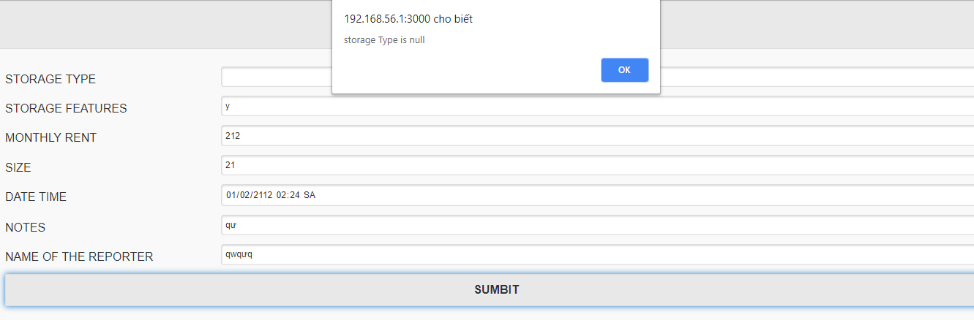

**2.2 Code that you wrote**

<body>

<section id="page" data-role="page">

<header data-role="header">

<h1>DInh ngoc Hung- GCH15253</h1>

<h1> PhoneGap App data entry screen </h1>

</header><!-- /header -->

<article role="main" class="ui-content">

<div data-role="fieldcontain">

<label for="textBox">storage type</label>

<input type="text" name="textBox" id="storageType" value="" required />

</div>

<div data-role="fieldcontain">

<label for="textBox">Storage features</label>

<input type="text" name="textBox" id="storageFeatures" value="" />

</div>

<div data-role="fieldcontain">

<label for="textBox">Monthly rent</label>

<input type="number" name="textBox" id="MrP" value="" />

</div>

<div data-role="fieldcontain">

<label for="textBox">Size</label>

<input type="number" name="textBox" id="dimensions" value="" />

</div>

<div data-role="fieldcontain">

<label for="textBox">Date time</label>

<input type="datetime-local" name="textBox" id="DaT" value="" />

</div>

<div data-role="fieldcontain">

<label for="textBox">Notes</label>

<input type="text" name="textBox" id="notes" value="" />

</div>

<div data-role="fieldcontain">

<label for="textBox">Name of the reporter</label>

<input type="text" name="textBox" id="nameOfTheReporter" value="" />

</div>

<a href="#" class="ui-btn" id="submit">Sumbit</a>

</article><!-- /content -->

<footer data-role="footer">

</footer><!-- /footer -->

</section><!-- /page -->

<script type="text/javascript" src="cordova.js"></script>

<script type="text/javascript" src="js/index.js"></script>

</body>

**Function code**

$("#submit").click(function(event) {

if($("#storageType").val() == "") {

alert("storage Type is null");

return false;

}

if($("#dimensions").val() == "") {

alert("dimensions is null");

return false;

}

if($("#DaT").val() == "") {

alert("DaT is null");

return false;

}

if($("#storageFeatures").val() == "") {

alert("storage Features is null");

return false;

}

if($("#storageType").val() == "") {

alert("storageType is null");

return false;

}

if($("#MrP").val() == "") {

alert("MrP is null");

return false;

}

if($("#nameOfTheReporter").val() == "") {

alert("Name Of The Reporter is null");

return false;

}

});

Exercise 3: Create a SQLite database to store the event details entered into the MyStorage App

1. **Basic Information**

|  |  |
| --- | --- |
| 1.1 Student name | **DINH NGOC HUNG Login id: GCH15253** |
| 1.2 Who did you work with? Note that for logbook exercises you are allowed to work with one other person as long as you give their name and login id and both contribute to the work. You need to provide evidence who did what. | **independent** |
| 1.3 Which Exercise is this? Tick as appropriate. | Create a SQLite database to store the event details entered into the MyStorage App |
| 1.4 How well did you complete the exercise? Tick as appropriate. | * I tried but couldn't complete it * I did it but I feel I should have done better * I did everything that was asked * I did more than was asked for |
| 1.5 Briefly explain your answer to question 1.4 |  |

1. **Exercise answer**
   1. **Screen shots demonstrating what you achieved**

**2.2 Code that you wrote**